Application Form of SIST Seminar
Title
Speaker |  | Inviter
Time |  | Venue | SIST 1A 200 (default) Please book via egate by applicant self before submitting the application form  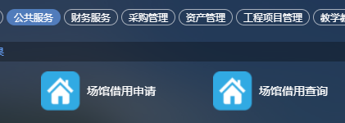
Email |  | Photo | Please Attach in email
Abstract
Bio
Other Request
Please email this application form and the speaker’s photo to SIST’s Academic Seminar Committee.
(to gaofei@shanghaitech.edu.cn cc to wangzx2@shanghaitech.edu.cn xueying@shanghaitech.edu.cn )
Suggested time slots (fall 2018): Fri 9-10 am, M/Tu/Th 14-15.
Others: CS, Tu/Th 1-3 pm, F 9-12; EEE, M/W 3-5 pm, M/Tu/Th 10-12; EES, M/W 1-3 pm, M 10-12, W/F 9-10.

